Project 7: Designing a Fountain

Part 1: Introduction to Fountain Design
The trapezoid represents the statue and the red dot is the location of the water jet.

- What would you need to know in order to write an equation for a path for the water that would make it go over the statue?
- What is a reasonable height of the statue and a reasonable distance from the jet to the statue?
- What strategy would you use to find the equation for the path of the water?

Part 2: Design a Fountain
A nearby park has a decorative pool, and the board of commissioners of the park is considering installing water jets in the pool to make it into a fountain. They have asked you to design the water jets. Here is a diagram of the pool from above:
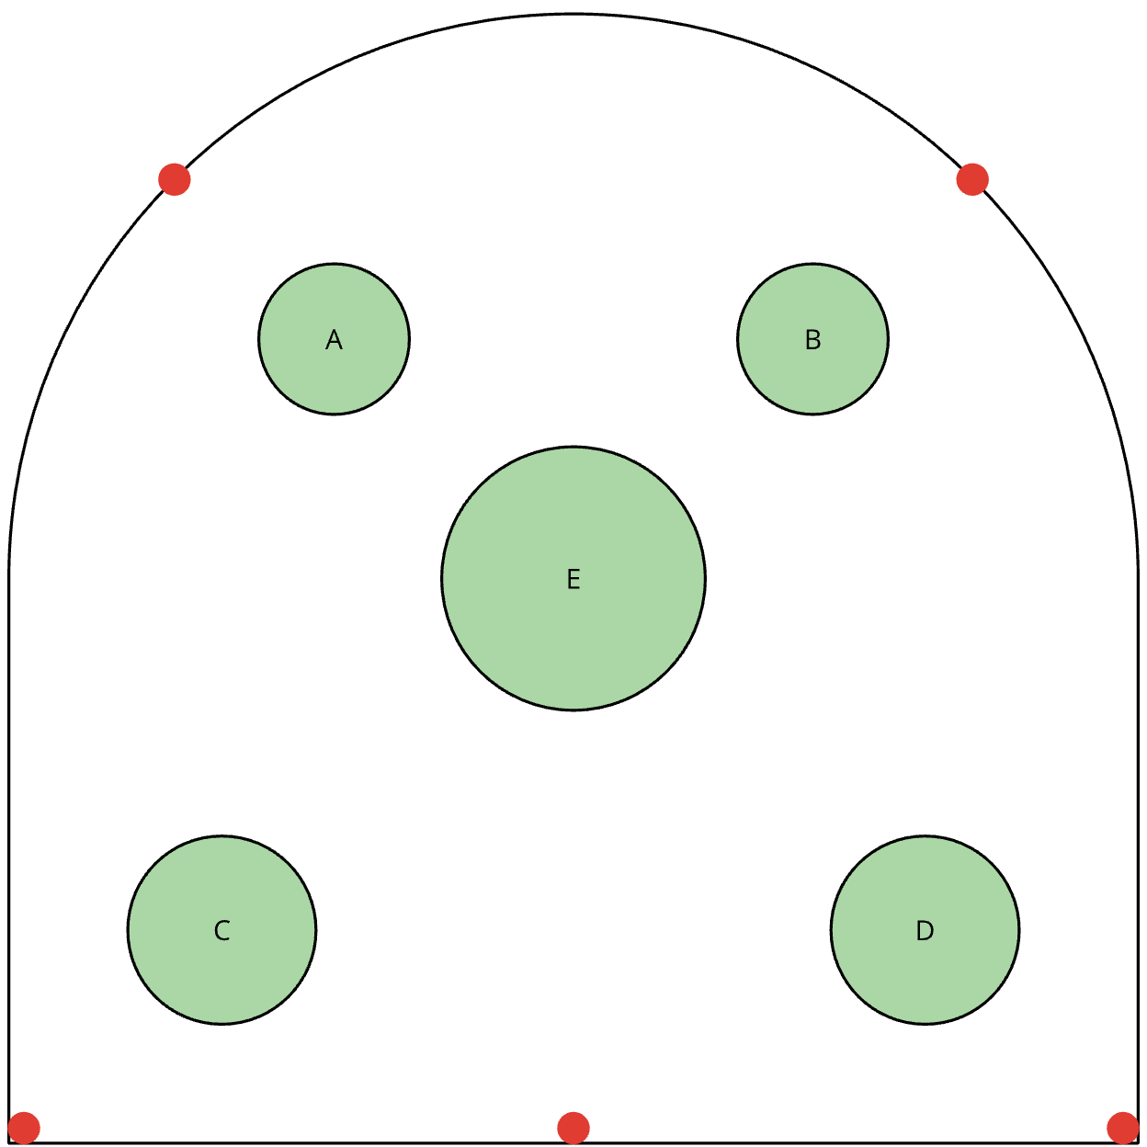

Diagram Description
The diagram shows a pool viewed from above with a rounded top and flat bottom edge. There are five statues inside the pool. Statues A and B are near the top left and top right, C is near the bottom left, D is near the bottom right, and E is in the center.
Dots along the edge indicate where water jets can be placed. These appear along both the curved top and flat bottom edges.
The pool is 15 feet wide. Statues A and B are 4 feet tall, C and D are 5.5 feet tall, and E is 8 feet tall with a vase.
The diagram is drawn to scale. Water jets must follow constraints including avoiding statues, staying within height limits, and reaching the vase.
You will need to figure out how many jets there should be, where they should go, and what path the water should make. Your design needs to meet these criteria:
- The jets can only go in the places indicated by the dots.
- There must be at least two jets.
- The water can’t hit any of the statues.
- Some water must go into the vase.
- The water can’t go higher than 10 feet.
When you have your final design, you should create a presentation to explain it to the commissioners. The presentation should show the paths of the water and include your mathematical descriptions of the paths.
How did your work creating one fountain in part 1 help with your process in part 2 where you created multiple fountains?

